**Explain the following questions in two simple sentences**

1. What is the use of the git add command?

The git add command is used to stage changes in your working directory for the next commit. It tells Git to include updates to a particular file or files in the next commit.

1. Write the command to create a branch “feature-login”

| git branch feature-login |
| --- |

1. What is a pull request? Write the steps involved in creating a pull request.

A pull request is a way to propose changes to a codebase in a repository.

Steps:

1. fork the repository
2. clone your forked repo
3. create a new branch
4. make and commit changes
5. push the branch to your fork
6. create a pull request from your fork's branch to the original repo.
7. How do you add collaborators?
8. Go to the repository on GitHub
9. click on "Settings"
10. Then click on "Manage access"
11. Click on "Invite a collaborator" to add their GitHub username or email.
12. What is the command used to commit our changes in github repo?

| git commit -m "Your commit message" |
| --- |

1. Create a github account and repository to save all your assignment tasks. Example repository name: rg-assignments

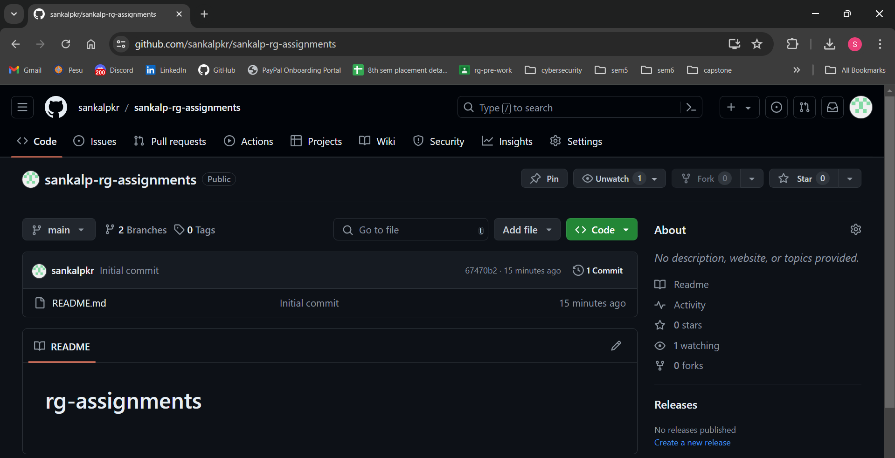

1. Create a branch called feature-java(you can use it later to push all your java related tasks to this branch)

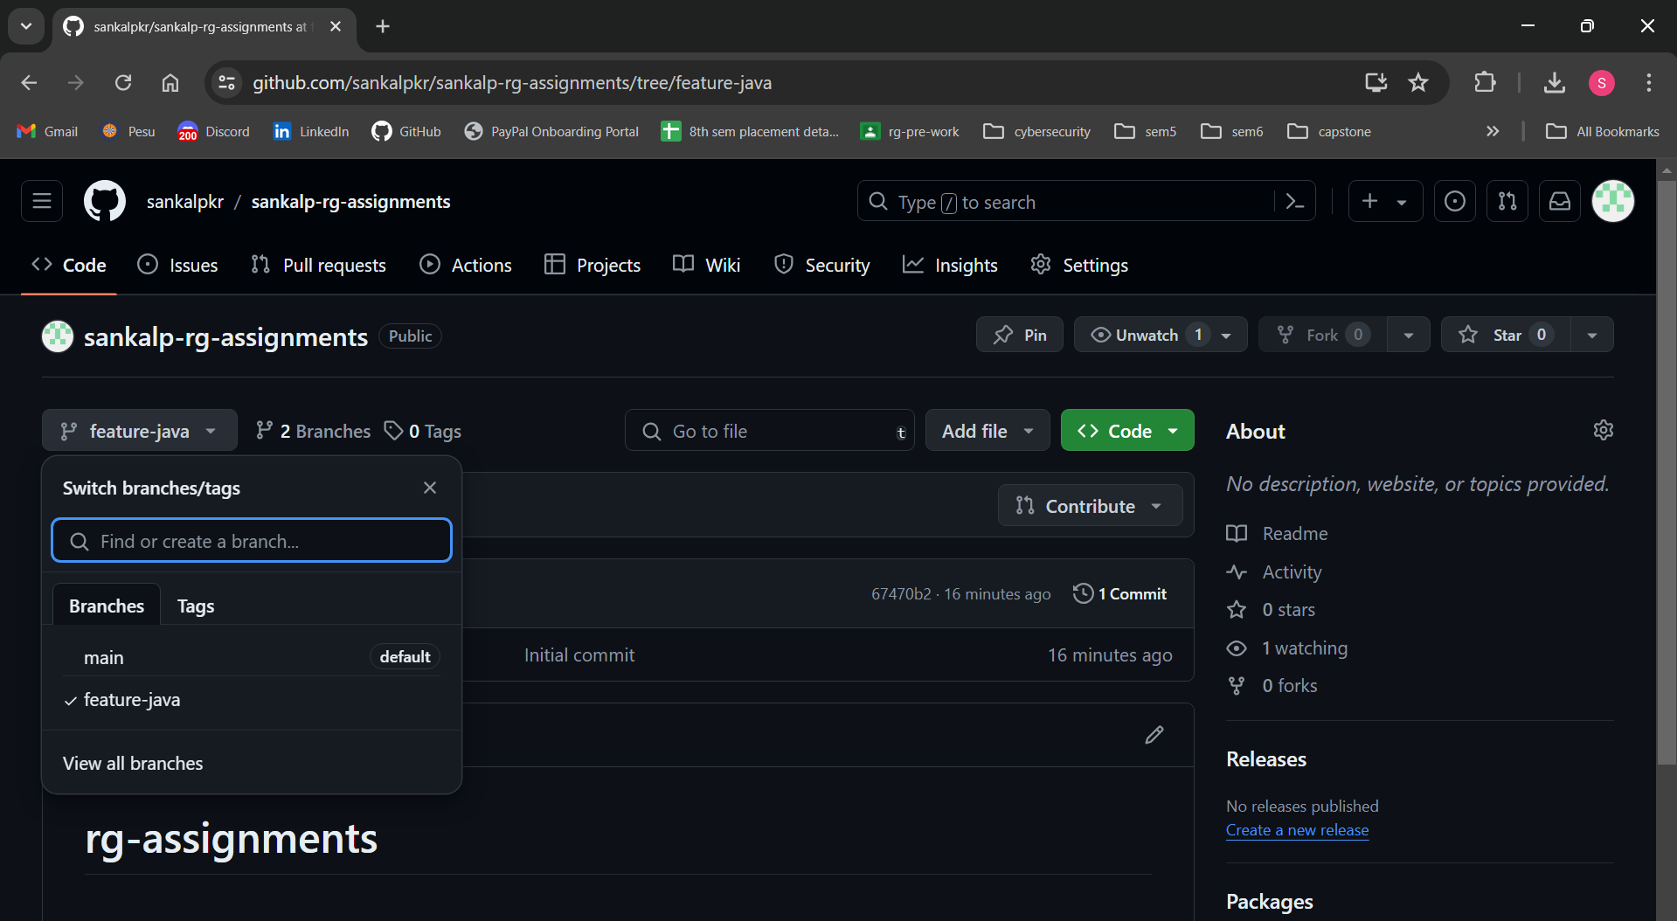

1. Install IntelliJ IDE. Create a simple java project displaying “Hello World!!”and share the screenshot.

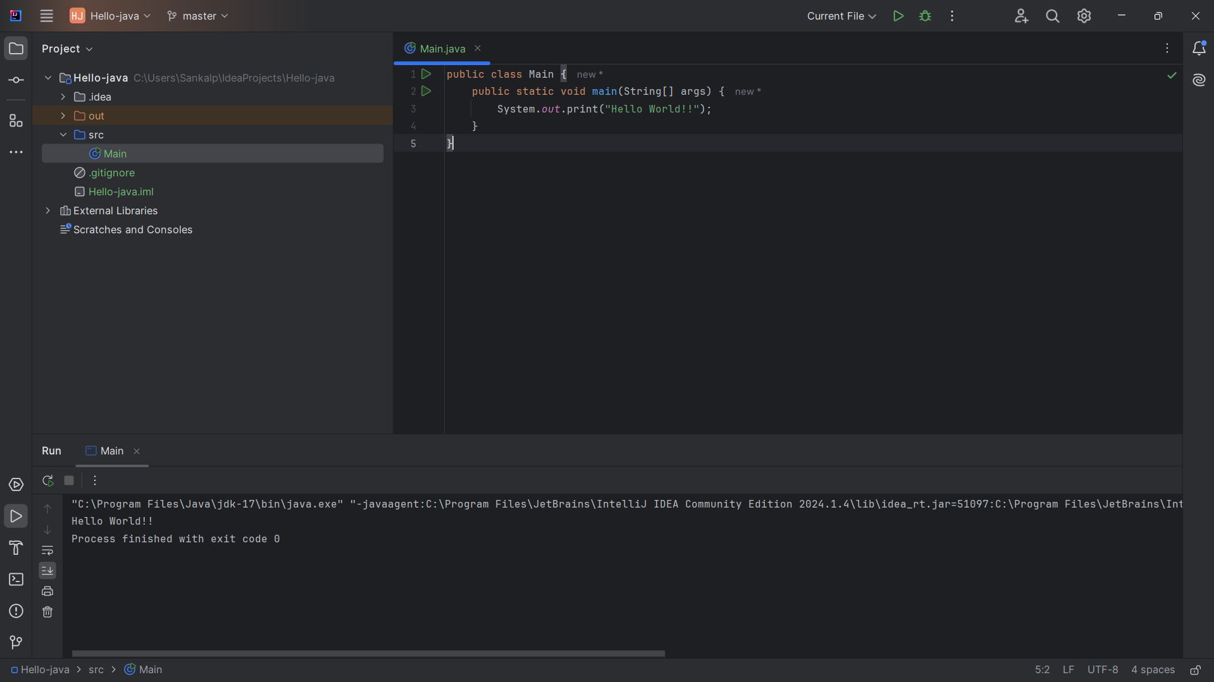

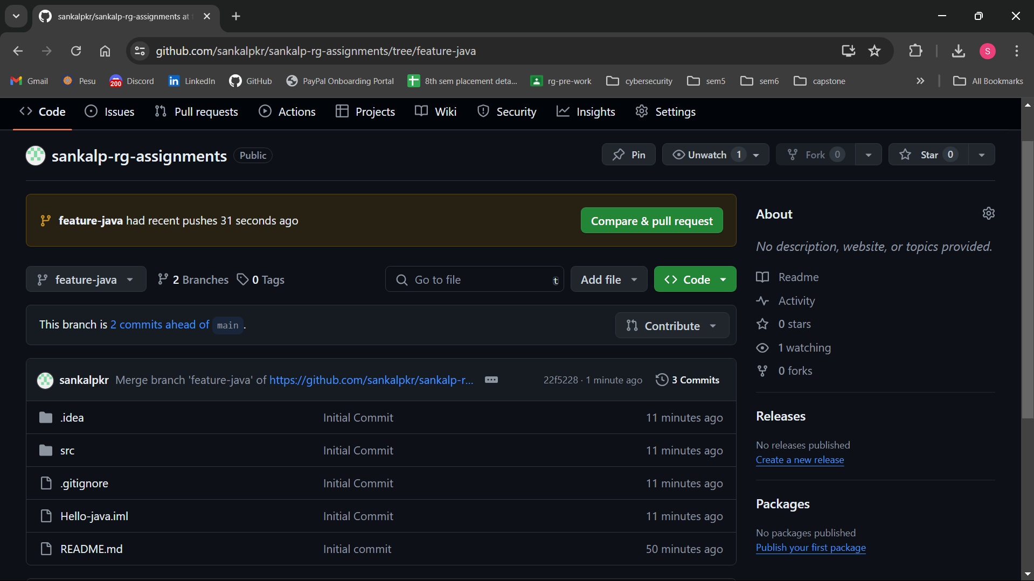

1. In IntelliJ IDE, explore the shortcut keys for the following
   1. To run the project - Shift (+ Fn) + F10
   2. To select a line - Ctrl + W
   3. To comment/uncomment a line - Ctrl + /
   4. To delete a line - Ctrl + W and backspace or Ctrl + Y